
Tertiary Infotech Academy Pte Ltd
UEN: 201200696W
LEARNER GUIDE
For
Wireshark Network Analysis Masterclass
Course Code: C1123
Conducted by
Tertiary Infotech Academy Pte Ltd
UEN: 201200696W
Version 5.1

DOCUMENT VERSION CONTROL RECORD
Version Number | Effective Date of Release | Summary of Included Changes | Author
4.0 | 2 October 2026 | Revised from the supplied v3 deck; current guidance, visuals and 18 self-contained labs. | Dr. Alfred Ang
5.0 | 5 October 2026 | Deck rebuilt on the house non-WSQ engine (C735 design system): full admin opener, core-concepts section, reference diagrams re-presented as captioned visuals, TShark evidence visuals per lab, per-topic schedule with day dividers and breaks. | Dr. Alfred Ang
5.1 | 5 October 2026 | Lab step slides replaced by scenario + summary slides (full steps in the LG and new per-lab instruction MD/PDF). About 40 new concept slides with visuals drawn from the lab captures; DHCP, NAT, IPv6, TShark, security patterns and baselining added from external sources. Per-lab scenario tickets, findings templates, TShark equivalents and optional extensions. | Dr. Alfred Ang

TABLE OF CONTENTS
Introduction 5
Course Learning Outcomes 5
Before You Start — Preparation 5
Topic 01 — Introduction to Network Analysis and Wireshark 6
Lab 1 — Establish a trace baseline 6
Topic 02 — Capture Methods and Capture Filters 8
Lab 2 — Plan capture placement 9
Topic 03 — Global Preferences and Troubleshooting Profiles 11
Lab 3 — Create an analyst profile 11
Topic 04 — Navigation and Coloring Techniques 13
Lab 4 — Color and annotate evidence 14
Topic 05 — Time Values and Delay Types 15
Lab 5 — Separate path and server delay 16
Topic 06 — Trace Statistics and VoIP Overview 18
Lab 6 — Summarize traffic and a voice stream 18
Topic 07 — Display Filters 20
Lab 7 — Build a filter evidence matrix 20
Topic 08 — TCP/IP Communications and Resolution 22
Lab 8 — Reconstruct an application dependency chain 23
Topic 09 — DNS Traffic Analysis 25
Lab 9 — Diagnose DNS failure and delay 25
Topic 10 — ARP Traffic Analysis 27
Lab 10 — Verify link-local resolution 27
Topic 11 — IPv4 Traffic Analysis 29
Lab 11 — Classify IPv4 scope and headers 29
Topic 12 — ICMP Traffic Analysis 31
Lab 12 — Interpret echo and unreachable messages 31
Topic 13 — UDP Traffic Analysis 33
Lab 13 — Follow datagrams and service refusal 33
Topic 14 — TCP Protocol Analysis 35
Lab 14 — Investigate retransmission and zero window 36
Topic 15 — Traffic Graphs 38
Lab 15 — Graph bytes, RTT and recovery 38
Topic 16 — HTTP and HTTP/2 Analysis 40
Lab 16 — Inspect HTTP outcomes and HTTP/2 frames 41
Topic 17 — TLS-Encrypted Traffic Analysis 42
Lab 17 — Compare encrypted and decrypted views 43
Topic 18 — Ten Troubleshooting Steps and Reporting 45
Lab 18 — Produce an evidence-led incident report 46
Next Steps 48
Further Learning 48
Glossary 48

Introduction
This guide supports C1123, a four-day, 30-hour commercial short course. It includes detailed instructions for 18 self-contained labs using supplied synthetic packet captures.
Version 5.0 aligns the slides, this guide and the lesson plan with the Tertiary Infotech house design. Every lab ships with its own synthetic capture, templates and verification script; the Expected Evidence figure in each lab shows the packet list you should reproduce.

Course Learning Outcomes
- LO1: Plan scoped captures and configure a reproducible analyst profile.
- LO2: Navigate, filter, summarize and time network exchanges.
- LO3: Interpret DNS, ARP, IPv4, ICMP and UDP evidence.
- LO4: Diagnose TCP and application behaviour, including HTTP and authorised TLS inspection.
- LO5: Report observed facts, hypotheses and next actions with defensible evidence.

Before You Start — Preparation
What you need
- Windows or macOS laptop; Wireshark 4.6 or later from https://www.wireshark.org/download.html.
- TShark CLI tools for automated fixture checks; Python 3 for scripts. Scapy and OpenSSL only if regenerating data.
- Download the whole labs folder so captures, templates and scripts stay together.
Verify your setup
Confirm Wireshark opens branch-office.pcap. For command-line checks use:
tshark --version
python3 --version
Conventions used in every lab
- Windows: use py -3 instead of python3. If tshark is not on PATH, use the Wireshark installation directory.
- All packet addresses and names are synthetic. The generator sends no packets.
- Steps assume you are inside the current lab folder. Clear filters between investigations.
- 4 days include 450 instructional minutes and 30 minutes of tea breaks each day; lunch is separate.

Topic 01 — Introduction to Network Analysis and Wireshark
Establish a trace baseline
Key concepts
- A capture is a measurement at one observation point, not a complete network history.
- Packet list, protocol details and bytes connect a summary to the underlying evidence.
- Record interface, timestamp precision, dropped packets and capture scope before interpreting a trace.
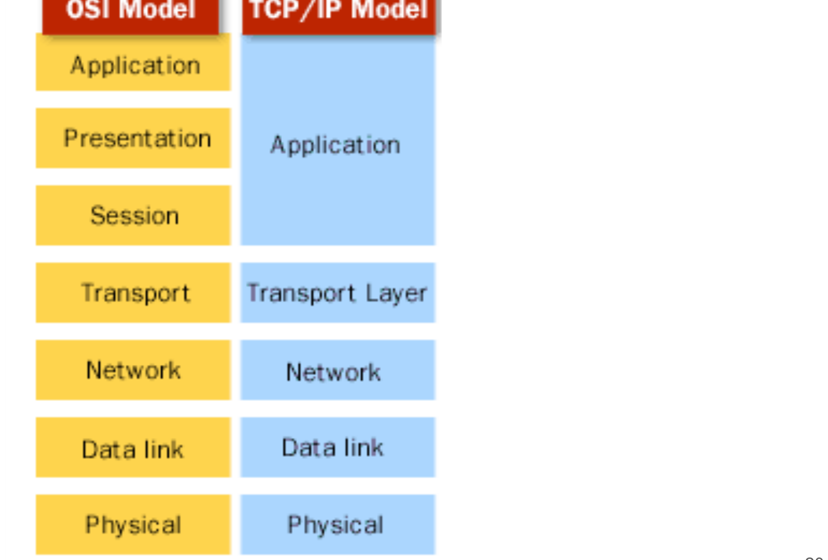
The TCP/IP and OSI Models — OSI layers mapped to the TCP/IP model

Lab 1 — Establish a trace baseline
Learning outcome: LO1.
Goal: A capture is a measurement at one observation point, not a complete network history.
What you'll build
Evidence CSV and packet findings (Tools: Wireshark, TShark, Python.)
Step-by-step
1. Prepare your lab workspace. Open this lab folder in a terminal. Windows uses py -3 in place of python3. Wireshark GUI alone is sufficient for the investigation; CLI scripts require TShark on PATH. Run the fixture verification first.
python3 scripts/verify.py
2. Open data/branch-office.pcap with File > Open. Clear the display filter. Record the packet count from the status bar and the capture duration from Statistics > Capture File Properties.
3. Select frame 1. Expand Ethernet II and Address Resolution Protocol in Packet Details. Click the sender IP field and observe the corresponding bytes.
4. Apply arp in the display filter toolbar. Compare request and reply sender/target IP and MAC addresses. Save the two frame numbers in outputs/findings.md.
5. Export a reproducible packet table. Record the filter, frame numbers, measurement, explanation and limitation in outputs/findings.md.
python3 scripts/export_evidence.py
Test it
The supplied arp expression matches 2 frame(s) in the specified capture. Run scripts/verify.py and compare the listed frame numbers. Keep your findings and exported table in outputs/. Explain the observed result rather than only copying a count.
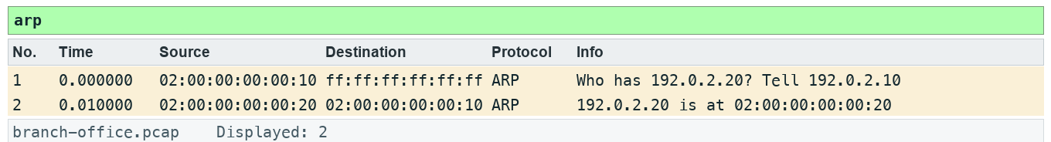
Lab 1 expected evidence — the packet list your filter should produce
Troubleshooting
TShark not found: install Wireshark CLI tools and add the installation folder to PATH; on Windows use the Wireshark install directory. A filter returns zero: clear other filters, use the specified capture, and check the expression is in the display toolbar. TLS remains opaque: select the matching lab-tls.keys file by absolute path, reload, and remove a key-log preference from another lab.
Try it with TShark
tshark -n -r data/branch-office.pcap -Y arp
Challenge
Develop and explain an alternative filter.
Reflection
Which second observation point would strengthen your conclusion?
Extension (optional)
Getting Started lab — capture your own short baseline on an authorised network and compare its protocol mix with this file. Source: J.F. Kurose and K.W. Ross, Wireshark Labs (gaia.cs.umass.edu/kurose_ross/wireshark.php).
Note: Printable copy: labs/lab-01-establish-a-trace-baseline/LAB-01-Instructions.pdf. Use the README in the matching labs/lab-NN-title/ folder. Capture only with permission.

Topic 02 — Capture Methods and Capture Filters
Plan capture placement
Key concepts
- A switched access port normally observes its own traffic and broadcasts; SPAN or TAP placement changes visibility.
- Capture filters use libpcap syntax before packets are stored; display filters hide or show stored packets.
- Bound file size and duration; check capture drops before attributing missing packets to network loss.
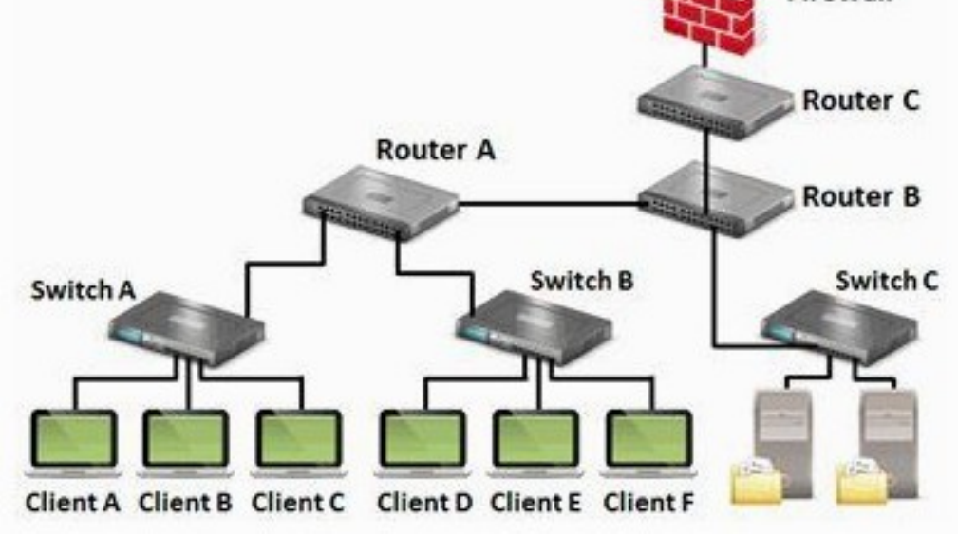
Where to Tap Into the Network — Choose the observation point before you capture

Lab 2 — Plan capture placement
Learning outcome: LO1.
Goal: A switched access port normally observes its own traffic and broadcasts; SPAN or TAP placement changes visibility.
What you'll build
Evidence CSV and packet findings (Tools: Wireshark, TShark, Python.)
Step-by-step
1. Prepare your lab workspace. Open this lab folder in a terminal. Windows uses py -3 in place of python3. Wireshark GUI alone is sufficient for the investigation; CLI scripts require TShark on PATH. Run the fixture verification first.
python3 scripts/verify.py
2. Open assets/topology.md. Draw a sensor on the client access port, on a mirrored uplink and beside the server. State which traffic each sees.
3. Open Capture > Options and inspect the interface list without starting a capture. Enter tcp port 80 in the capture-filter box and check syntax feedback. Cancel the dialog.
4. Open data/branch-office.pcap. Enter tcp.port == 80 in the DISPLAY toolbar. Compare the stored total with the displayed total; explain why clearing it restores hidden packets.
5. Complete assets/capture-plan.md with scope, interface, duration, ring-buffer limit and permission owner. Wireless monitor mode requires compatible adapter/driver; USB capture requires platform-specific support. Remote capture should use authorised SSH/extcap, not obsolete unauthenticated RPC instructions.
6. Export a reproducible packet table. Record the filter, frame numbers, measurement, explanation and limitation in outputs/findings.md.
python3 scripts/export_evidence.py
Test it
The supplied tcp.port == 80 expression matches 37 frame(s) in the specified capture. Run scripts/verify.py and compare the listed frame numbers. Keep your findings and exported table in outputs/. Explain the observed result rather than only copying a count.
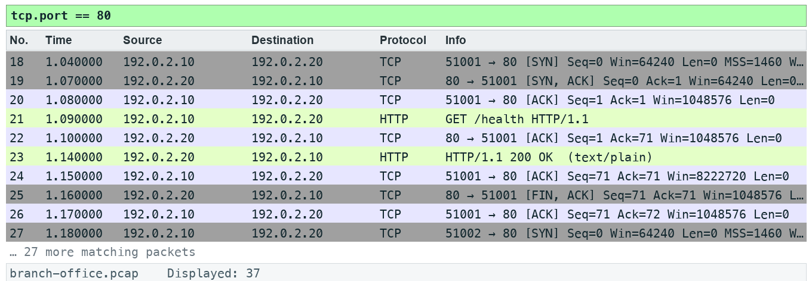
Lab 2 expected evidence — the packet list your filter should produce
Troubleshooting
TShark not found: install Wireshark CLI tools and add the installation folder to PATH; on Windows use the Wireshark install directory. A filter returns zero: clear other filters, use the specified capture, and check the expression is in the display toolbar. TLS remains opaque: select the matching lab-tls.keys file by absolute path, reload, and remove a key-log preference from another lab.
Try it with TShark
tshark -D
Challenge
Develop and explain an alternative filter.
Reflection
Which second observation point would strengthen your conclusion?
Extension (optional)
Getting Started lab — list your interfaces and identify which one carries traffic before planning a capture. Source: J.F. Kurose and K.W. Ross, Wireshark Labs (gaia.cs.umass.edu/kurose_ross/wireshark.php).
Note: Printable copy: labs/lab-02-plan-capture-placement/LAB-02-Instructions.pdf. Use the README in the matching labs/lab-NN-title/ folder. Capture only with permission.

Topic 03 — Global Preferences and Troubleshooting Profiles
Create an analyst profile
Key concepts
- A profile bundles reproducible columns, coloring rules and protocol settings.
- Name resolution can obscure numeric evidence and generate additional traffic; document the setting.
- Protocol heuristics and TCP analysis preferences change interpretation, not the stored bytes.
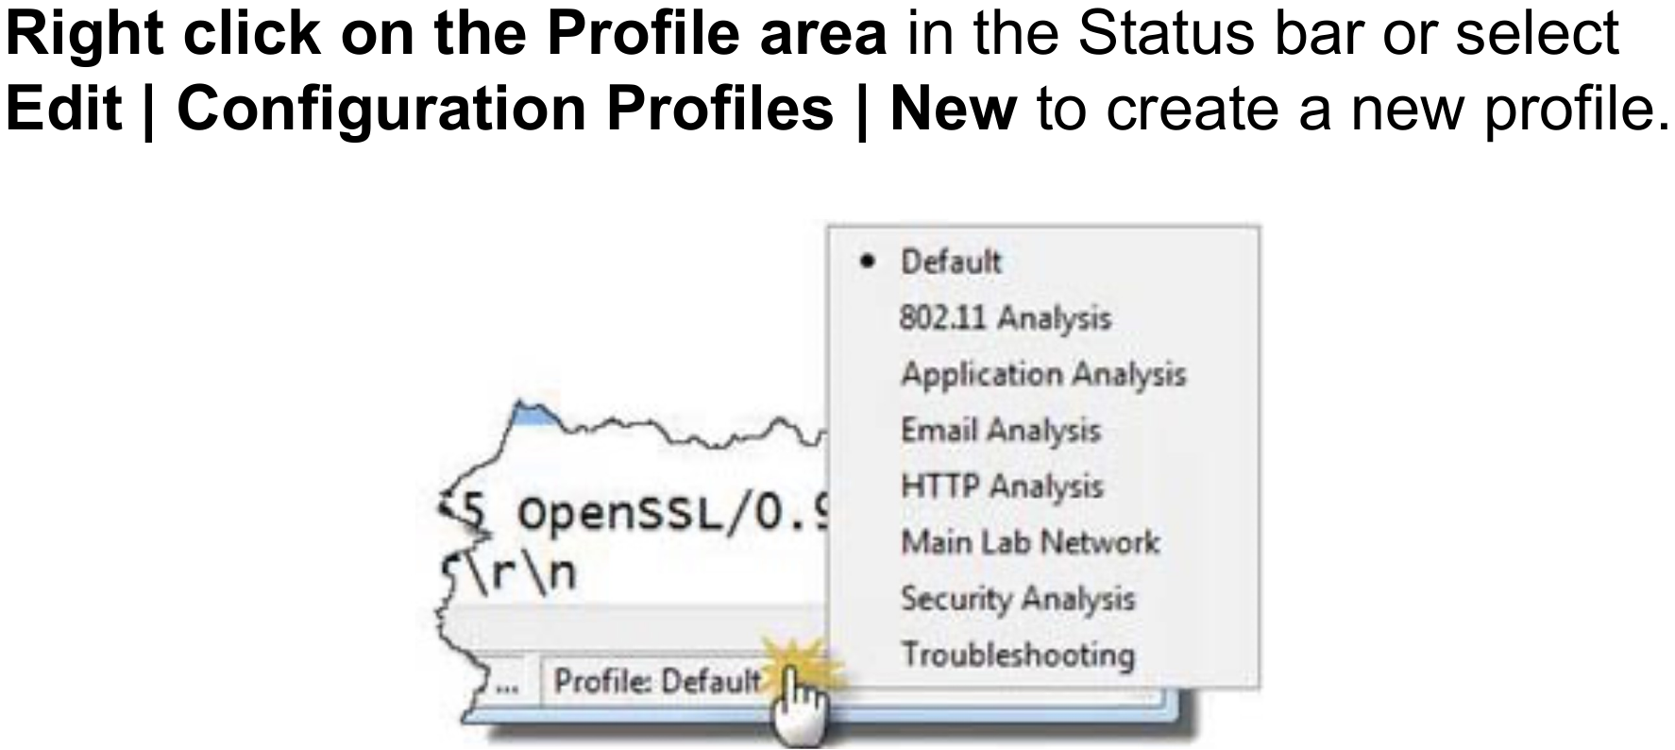
Configuration Profiles — Right-click the Profile area in the status bar to switch or create

Lab 3 — Create an analyst profile
Learning outcome: LO1.
Goal: A profile bundles reproducible columns, coloring rules and protocol settings.
What you'll build
Evidence CSV and packet findings (Tools: Wireshark, TShark, Python.)
Step-by-step
1. Prepare your lab workspace. Open this lab folder in a terminal. Windows uses py -3 in place of python3. Wireshark GUI alone is sufficient for the investigation; CLI scripts require TShark on PATH. Run the fixture verification first.
python3 scripts/verify.py
2. Create a profile named C1123-Analyst using Edit > Configuration Profiles. Keep the original profile available.
3. Open data/branch-office.pcap. Disable network name resolution in View > Name Resolution. Record numeric client, server and resolver IP addresses.
4. Select a TCP packet. Expand TCP and right-click Stream index > Apply as Column. Add frame.time_delta_displayed as a custom column using Preferences > Appearance > Columns.
5. Apply dns and inspect the profile name and displayed columns. Copy the profile folder path from Help > About Wireshark > Folders into outputs/findings.md. Export or copy your profile to outputs/profile/ without overwriting a colleague profile.
6. Export a reproducible packet table. Record the filter, frame numbers, measurement, explanation and limitation in outputs/findings.md.
python3 scripts/export_evidence.py
Test it
The supplied dns expression matches 6 frame(s) in the specified capture. Run scripts/verify.py and compare the listed frame numbers. Keep your findings and exported table in outputs/. Explain the observed result rather than only copying a count.
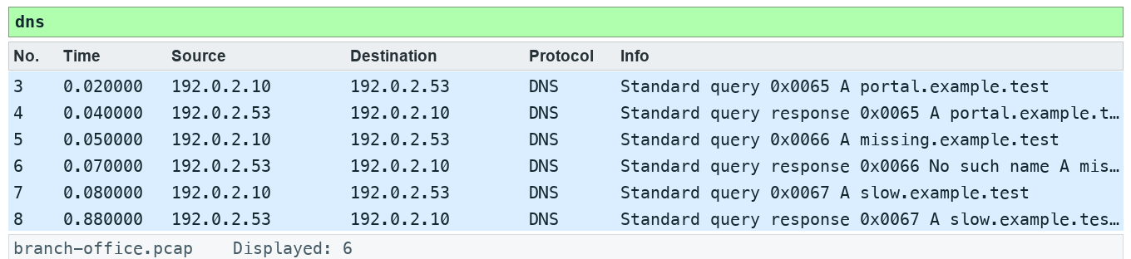
Lab 3 expected evidence — the packet list your filter should produce
Troubleshooting
TShark not found: install Wireshark CLI tools and add the installation folder to PATH; on Windows use the Wireshark install directory. A filter returns zero: clear other filters, use the specified capture, and check the expression is in the display toolbar. TLS remains opaque: select the matching lab-tls.keys file by absolute path, reload, and remove a key-log preference from another lab.
Try it with TShark
tshark -n -r data/branch-office.pcap -Y dns -T fields -e frame.number -e ip.src -e ip.dst -e dns.qry.name
Challenge
Develop and explain an alternative filter.
Reflection
Which second observation point would strengthen your conclusion?
Extension (optional)
Export your C1123-Analyst profile folder and import it on a second machine; confirm the columns appear.
Note: Printable copy: labs/lab-03-create-an-analyst-profile/LAB-03-Instructions.pdf. Use the README in the matching labs/lab-NN-title/ folder. Capture only with permission.

Topic 04 — Navigation and Coloring Techniques
Color and annotate evidence
Key concepts
- Color rules are applied in order; the first matching rule wins.
- Temporary coloring is useful for a conversation; permanent rules support repeated triage.
- Bookmarks and comments preserve the analyst path without changing the captured payload.
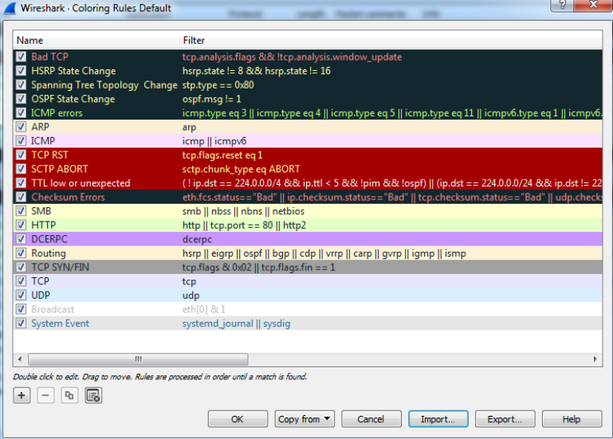
Colouring Rules — The coloring rules list is processed in order

Lab 4 — Color and annotate evidence
Learning outcome: LO1.
Goal: Color rules are applied in order; the first matching rule wins.
What you'll build
Evidence CSV and packet findings (Tools: Wireshark, TShark, Python.)
Step-by-step
1. Prepare your lab workspace. Open this lab folder in a terminal. Windows uses py -3 in place of python3. Wireshark GUI alone is sufficient for the investigation; CLI scripts require TShark on PATH. Run the fixture verification first.
python3 scripts/verify.py
2. Open data/branch-office.pcap. Apply http.response.code >= 400. Record the 404 and 500 frame numbers.
3. Open View > Coloring Rules. Add LAB HTTP Error with expression http.response.code >= 400, dark text and a pale amber background. Move it above a general HTTP rule.
4. Select the 500 response, mark it using Edit > Mark/Unmark Packet and add a packet comment describing the observed status only. Save As outputs/annotated.pcapng to preserve comments.
5. Clear the filter. Use Edit > Find Packet with Display filter http.response.code == 500. Reopen the saved pcapng and confirm the comment persists.
6. Export a reproducible packet table. Record the filter, frame numbers, measurement, explanation and limitation in outputs/findings.md.
python3 scripts/export_evidence.py
Test it
The supplied http.response.code >= 400 expression matches 2 frame(s) in the specified capture. Run scripts/verify.py and compare the listed frame numbers. Keep your findings and exported table in outputs/. Explain the observed result rather than only copying a count.
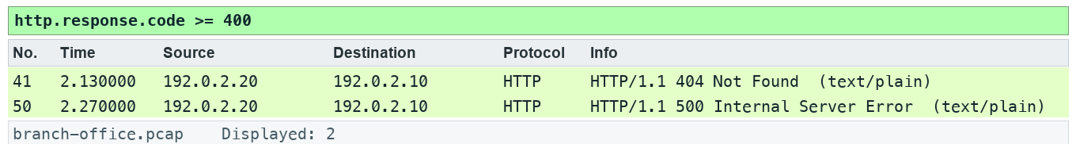
Lab 4 expected evidence — the packet list your filter should produce
Troubleshooting
TShark not found: install Wireshark CLI tools and add the installation folder to PATH; on Windows use the Wireshark install directory. A filter returns zero: clear other filters, use the specified capture, and check the expression is in the display toolbar. TLS remains opaque: select the matching lab-tls.keys file by absolute path, reload, and remove a key-log preference from another lab.
Try it with TShark
tshark -n -r data/branch-office.pcap -Y "http.response.code >= 400" -T fields -e frame.number -e http.response.code -e http.request_in -e http.time
Challenge
Develop and explain an alternative filter.
Reflection
Which second observation point would strengthen your conclusion?
Extension (optional)
HTTP lab — apply your LAB HTTP Error rule to the HTTP trace from the Kurose & Ross labs. Source: J.F. Kurose and K.W. Ross, Wireshark Labs (gaia.cs.umass.edu/kurose_ross/wireshark.php).
Note: Printable copy: labs/lab-04-color-and-annotate-evidence/LAB-04-Instructions.pdf. Use the README in the matching labs/lab-NN-title/ folder. Capture only with permission.

Topic 05 — Time Values and Delay Types
Separate path and server delay
Key concepts
- Displayed delta depends on the current filter; capture delta does not.
- SYN to SYN/ACK gives an initial path-related sample; request to response includes application processing.
- One-sided timestamps cannot identify exactly which intermediate device delayed or dropped a packet.
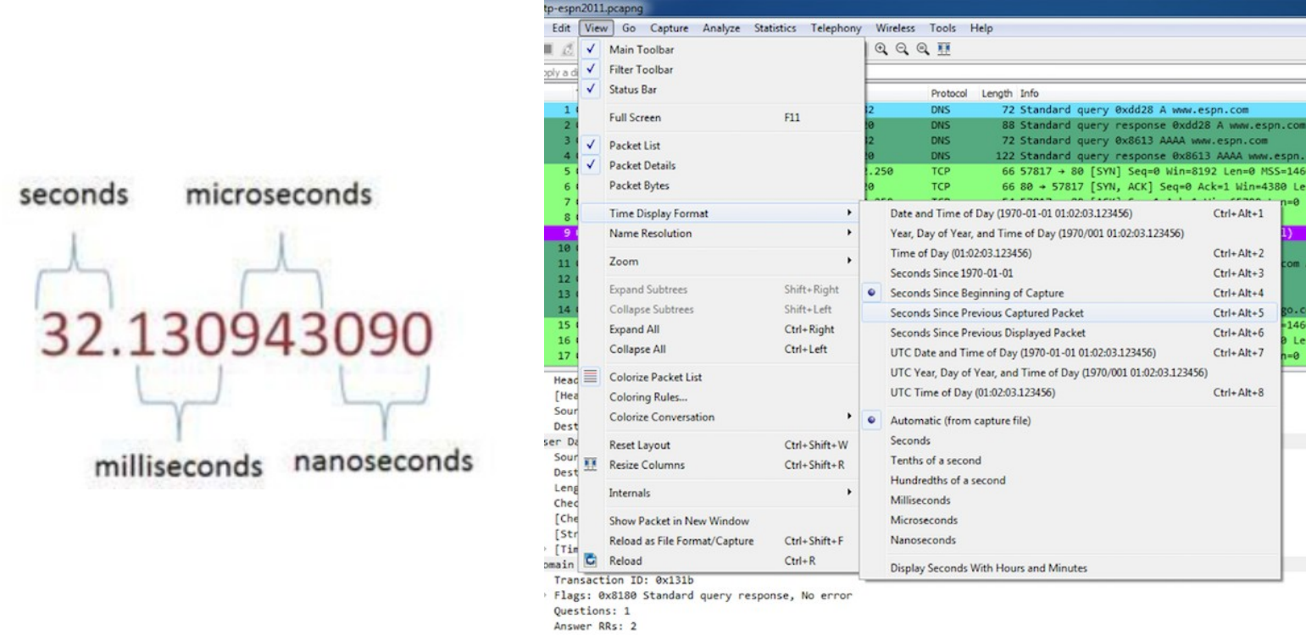
Time Display Formats — Precision depends on the capture hardware and file format

Lab 5 — Separate path and server delay
Learning outcome: LO2.
Goal: Displayed delta depends on the current filter; capture delta does not.
What you'll build
Evidence CSV and packet findings (Tools: Wireshark, TShark, Python.)
Step-by-step
1. Prepare your lab workspace. Open this lab folder in a terminal. Windows uses py -3 in place of python3. Wireshark GUI alone is sufficient for the investigation; CLI scripts require TShark on PATH. Run the fixture verification first.
python3 scripts/verify.py
2. Open data/branch-office.pcap. Apply tcp.stream == 1. Expand TCP in the final handshake ACK and inspect tcp.analysis.initial_rtt: 0.040 seconds. Separately measure SYN to SYN/ACK by setting a time reference on the SYN: 0.030 seconds.
3. Locate GET /slow and its HTTP response. Set a new time reference on the request. Record the response delta: 0.760 seconds, including 0.010 seconds to the server ACK and 0.750 seconds thereafter.
4. Apply http.request.uri == "/slow" || http.response.code == 200 and compare frame.time_delta with frame.time_delta_displayed on the filtered list. Explain why a displayed gap can span hidden packets.
5. Write a hypothesis in outputs/findings.md: slow response with a synthetic 30 ms SYN-to-SYN/ACK interval and 40 ms complete handshake. Name a second observation point required to distinguish processing from a later path delay.
6. Export a reproducible packet table. Record the filter, frame numbers, measurement, explanation and limitation in outputs/findings.md.
python3 scripts/export_evidence.py
Test it
The supplied http.request.uri == "/slow" || http.response.code == 200 expression matches 3 frame(s) in the specified capture. Run scripts/verify.py and compare the listed frame numbers. Keep your findings and exported table in outputs/. Explain the observed result rather than only copying a count.
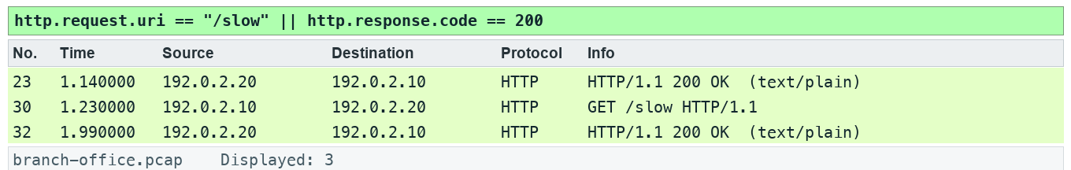
Lab 5 expected evidence — the packet list your filter should produce
Troubleshooting
TShark not found: install Wireshark CLI tools and add the installation folder to PATH; on Windows use the Wireshark install directory. A filter returns zero: clear other filters, use the specified capture, and check the expression is in the display toolbar. TLS remains opaque: select the matching lab-tls.keys file by absolute path, reload, and remove a key-log preference from another lab.
Try it with TShark
tshark -n -r data/branch-office.pcap -Y "tcp.stream == 1 && http.time" -T fields -e frame.number -e tcp.analysis.initial_rtt -e http.time
Challenge
Develop and explain an alternative filter.
Reflection
Which second observation point would strengthen your conclusion?
Extension (optional)
TCP lab — measure the initial RTT and response times in the TCP trace supplied with the Kurose & Ross labs. Source: J.F. Kurose and K.W. Ross, Wireshark Labs (gaia.cs.umass.edu/kurose_ross/wireshark.php).
Note: Printable copy: labs/lab-05-separate-path-and-server-delay/LAB-05-Instructions.pdf. Use the README in the matching labs/lab-NN-title/ folder. Capture only with permission.

Topic 06 — Trace Statistics and VoIP Overview
Summarize traffic and a voice stream
Key concepts
- Protocol Hierarchy shows captured composition; byte share differs from packet share.
- Conversations and Endpoints identify concentration; they do not alone prove malicious activity.
- SIP signals a call while RTP carries media; jitter, loss and codec interpretation need stream context.
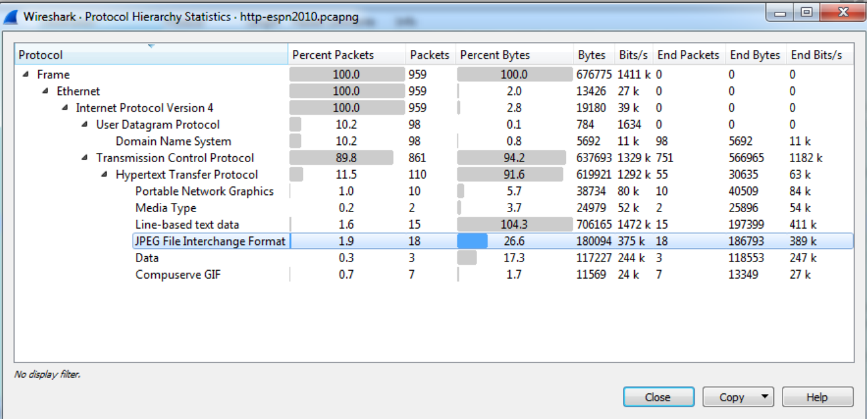
Capture File Properties — Statistics | Protocol Hierarchy shows the protocol mix

Lab 6 — Summarize traffic and a voice stream
Learning outcome: LO2.
Goal: Protocol Hierarchy shows captured composition; byte share differs from packet share.
What you'll build
Evidence CSV and packet findings (Tools: Wireshark, TShark, Python.)
Step-by-step
1. Prepare your lab workspace. Open this lab folder in a terminal. Windows uses py -3 in place of python3. Wireshark GUI alone is sufficient for the investigation; CLI scripts require TShark on PATH. Run the fixture verification first.
python3 scripts/verify.py
2. Open data/branch-office.pcap. Open Statistics > Protocol Hierarchy, then Statistics > Conversations. Sort TCP conversations by bytes; save the largest conversation details.
3. Open Statistics > I/O Graphs. Create an all-traffic graph with a 1 second interval and Bits as the unit. Record peak interval and explain the difference between observed bits and usable application throughput.
4. Apply sip and open Telephony > VoIP Calls or SIP Flows. Identify the INVITE and 200 OK. This minimal synthetic exchange is signalling evidence, not a complete production call.
5. Apply udp.port == 4002. Use Analyze > Decode As to decode this UDP port as RTP. Open Telephony > RTP > RTP Streams, select the stream and Analyze. Record sequence numbers 100, 101, 103, 104; the missing sequence is 102.
6. Export a reproducible packet table. Record the filter, frame numbers, measurement, explanation and limitation in outputs/findings.md.
python3 scripts/export_evidence.py
Test it
The supplied sip expression matches 2 frame(s) in the specified capture. Run scripts/verify.py and compare the listed frame numbers. Keep your findings and exported table in outputs/. Explain the observed result rather than only copying a count.
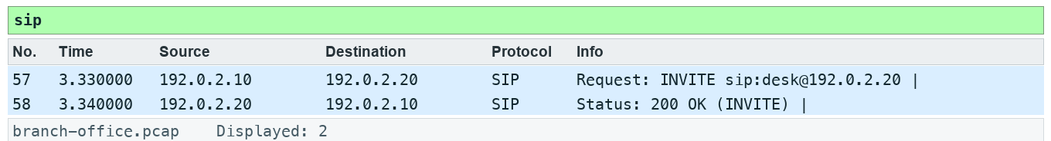
Lab 6 expected evidence — the packet list your filter should produce
Troubleshooting
TShark not found: install Wireshark CLI tools and add the installation folder to PATH; on Windows use the Wireshark install directory. A filter returns zero: clear other filters, use the specified capture, and check the expression is in the display toolbar. TLS remains opaque: select the matching lab-tls.keys file by absolute path, reload, and remove a key-log preference from another lab.
Try it with TShark
tshark -n -r data/branch-office.pcap -q -z io,phs
Challenge
Develop and explain an alternative filter.
Reflection
Which second observation point would strengthen your conclusion?
Extension (optional)
Analyse a longer SIP/RTP call from the Wireshark sample captures (wiki.wireshark.org/SampleCaptures) with Telephony > VoIP Calls.
Note: Printable copy: labs/lab-06-summarize-traffic-and-a-voice-stream/LAB-06-Instructions.pdf. Use the README in the matching labs/lab-NN-title/ folder. Capture only with permission.

Topic 07 — Display Filters
Build a filter evidence matrix
Key concepts
- Parentheses make mixed and/or expressions explicit.
- Field existence and Boolean equality differ: tcp.flags.syn == 1 tests the bit.
- Since Wireshark 3.6, != uses all-not-equal semantics; historical slides describing any-not-equal are obsolete.
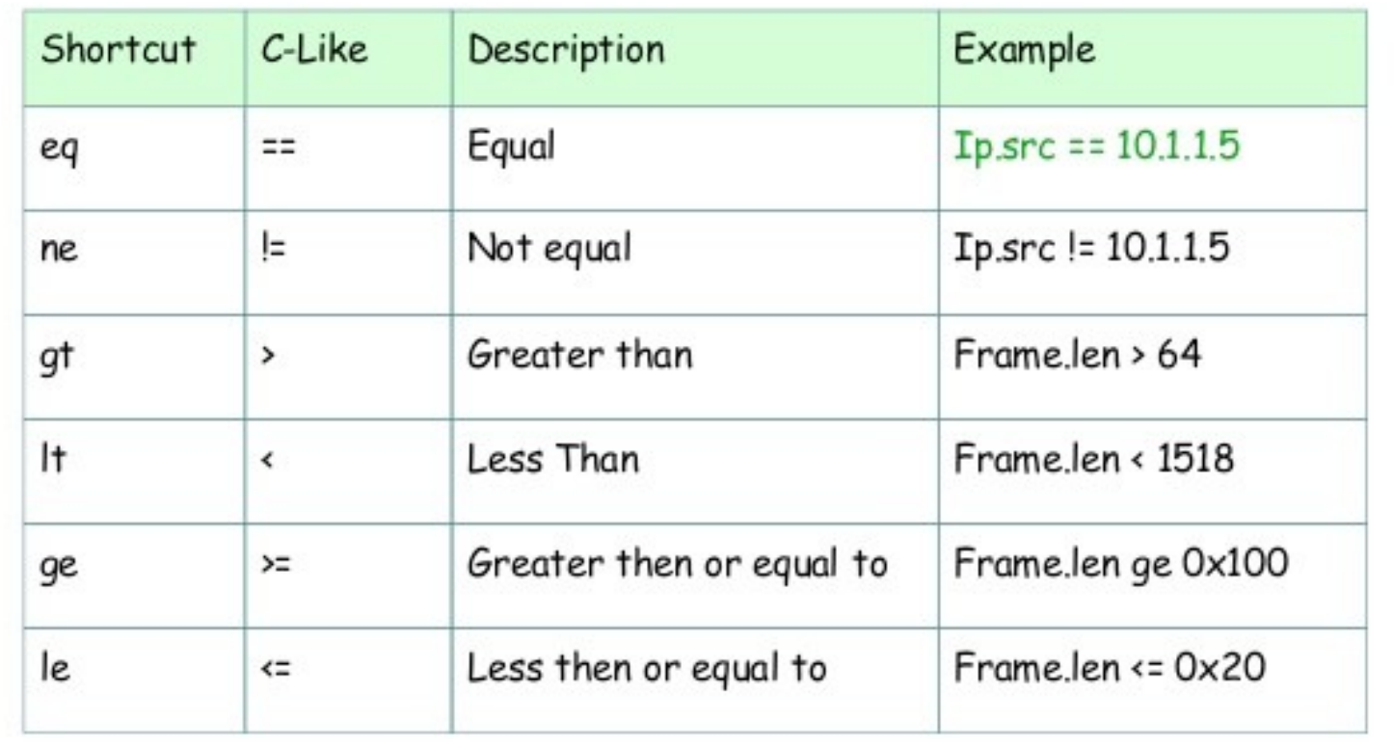
Display Filter Operators — Comparison operators with C-like and English forms

Lab 7 — Build a filter evidence matrix
Learning outcome: LO2.
Goal: Parentheses make mixed and/or expressions explicit.
What you'll build
Evidence CSV and packet findings (Tools: Wireshark, TShark, Python.)
Step-by-step
1. Prepare your lab workspace. Open this lab folder in a terminal. Windows uses py -3 in place of python3. Wireshark GUI alone is sufficient for the investigation; CLI scripts require TShark on PATH. Run the fixture verification first.
python3 scripts/verify.py
2. Open data/branch-office.pcap. Apply dns.flags.rcode == 3 and record the returned response frame. Clear the filter and apply tcp.flags.syn == 1.
3. Compare (ip.src == 192.0.2.10 && udp.port == 53) || tcp.port == 80 with ip.src == 192.0.2.10 && (udp.port == 53 || tcp.port == 80). Record both counts and the direction excluded by the second expression.
4. Apply !(ip.addr == 192.0.2.53). Verify that DNS packets disappear; compare ip.addr != 192.0.2.53 on Wireshark 4.6 or later. Record the actual version and equality behaviour.
5. Save five useful filters in outputs/filters.txt. For each, state the question, filter and matching frame numbers; compile them with scripts/verify.py.
6. Export a reproducible packet table. Record the filter, frame numbers, measurement, explanation and limitation in outputs/findings.md.
python3 scripts/export_evidence.py
Test it
The supplied dns.flags.rcode == 3 expression matches 1 frame(s) in the specified capture. Run scripts/verify.py and compare the listed frame numbers. Keep your findings and exported table in outputs/. Explain the observed result rather than only copying a count.
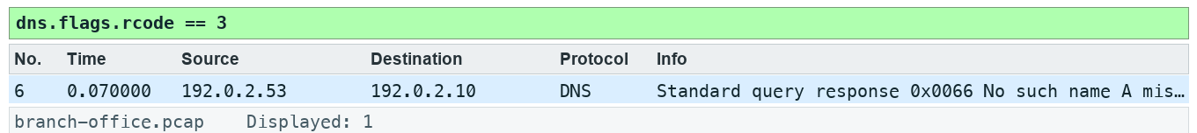
Lab 7 expected evidence — the packet list your filter should produce
Troubleshooting
TShark not found: install Wireshark CLI tools and add the installation folder to PATH; on Windows use the Wireshark install directory. A filter returns zero: clear other filters, use the specified capture, and check the expression is in the display toolbar. TLS remains opaque: select the matching lab-tls.keys file by absolute path, reload, and remove a key-log preference from another lab.
Try it with TShark
tshark -n -r data/branch-office.pcap -Y "dns.flags.rcode == 3"
Challenge
Develop and explain an alternative filter.
Reflection
Which second observation point would strengthen your conclusion?
Extension (optional)
Rewrite two of your matrix filters with the set (in {…}) and matches operators and confirm the frame lists are unchanged.
Note: Printable copy: labs/lab-07-build-a-filter-evidence-matrix/LAB-07-Instructions.pdf. Use the README in the matching labs/lab-NN-title/ folder. Capture only with permission.

Topic 08 — TCP/IP Communications and Resolution
Reconstruct an application dependency chain
Key concepts
- ARP resolves a local next-hop MAC; DNS resolves a name to an address.
- The destination IP stays end-to-end across routing while link-layer addresses change per hop.
- Resolution, connection establishment and application exchange form a dependency chain.
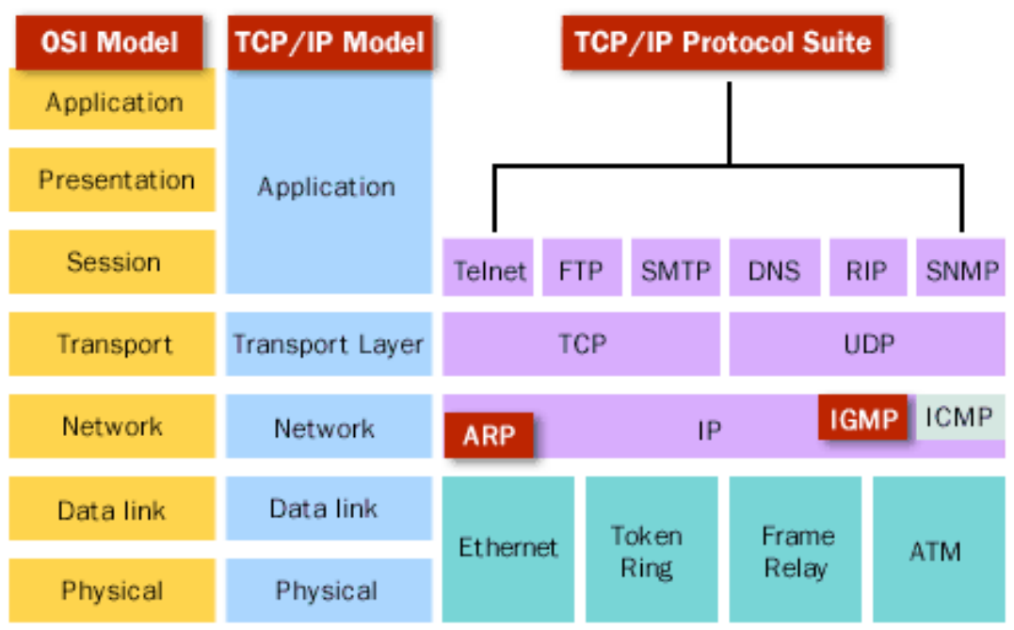
The TCP/IP Protocol Suite — Where common protocols sit

Lab 8 — Reconstruct an application dependency chain
Learning outcome: LO2.
Goal: ARP resolves a local next-hop MAC; DNS resolves a name to an address.
What you'll build
Evidence CSV and packet findings (Tools: Wireshark, TShark, Python.)
Step-by-step
1. Prepare your lab workspace. Open this lab folder in a terminal. Windows uses py -3 in place of python3. Wireshark GUI alone is sufficient for the investigation; CLI scripts require TShark on PATH. Run the fixture verification first.
python3 scripts/verify.py
2. Open data/branch-office.pcap. Locate the ARP exchange and DNS transaction 101 for portal.example.test. Record the server address 192.0.2.20.
3. Apply tcp.stream == 0 and open Statistics > Flow Graph with displayed packets selected. Identify SYN, SYN/ACK, ACK, request and response.
4. Fill assets/dependency-map.md with the ARP, DNS, TCP and HTTP frame ranges. Distinguish Ethernet next hop from IP destination.
5. Contrast a same-subnet server with a routed server using assets/topology.md: a routed destination needs the gateway MAC rather than ARP for the remote host. Record what this trace can and cannot demonstrate.
6. Export a reproducible packet table. Record the filter, frame numbers, measurement, explanation and limitation in outputs/findings.md.
python3 scripts/export_evidence.py
Test it
The supplied dns.qry.name == "portal.example.test" expression matches 2 frame(s) in the specified capture. Run scripts/verify.py and compare the listed frame numbers. Keep your findings and exported table in outputs/. Explain the observed result rather than only copying a count.
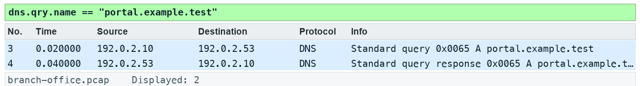
Lab 8 expected evidence — the packet list your filter should produce
Troubleshooting
TShark not found: install Wireshark CLI tools and add the installation folder to PATH; on Windows use the Wireshark install directory. A filter returns zero: clear other filters, use the specified capture, and check the expression is in the display toolbar. TLS remains opaque: select the matching lab-tls.keys file by absolute path, reload, and remove a key-log preference from another lab.
Try it with TShark
tshark -n -r data/branch-office.pcap -Y "arp || dns.id == 0x0065 || tcp.stream == 0"
Challenge
Develop and explain an alternative filter.
Reflection
Which second observation point would strengthen your conclusion?
Extension (optional)
Ethernet and ARP lab — trace the dependency chain for a page you load on an authorised network. Source: J.F. Kurose and K.W. Ross, Wireshark Labs (gaia.cs.umass.edu/kurose_ross/wireshark.php).
Note: Printable copy: labs/lab-08-reconstruct-an-application-dependency-chain/LAB-08-Instructions.pdf. Use the README in the matching labs/lab-NN-title/ folder. Capture only with permission.

Topic 09 — DNS Traffic Analysis
Diagnose DNS failure and delay
Key concepts
- Transaction ID plus addresses and ports pair a query with its response.
- NXDOMAIN reports that a name does not exist; it differs from silence or timeout.
- DNS response time is a measured exchange, influenced by resolver and path behaviour.
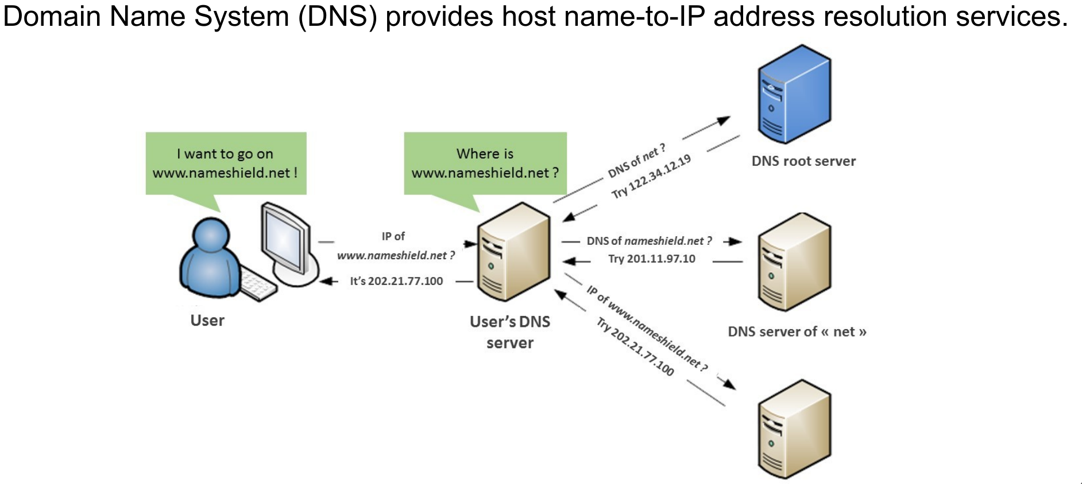
How DNS Works — Name resolution through a local resolver

Lab 9 — Diagnose DNS failure and delay
Learning outcome: LO3.
Goal: Transaction ID plus addresses and ports pair a query with its response.
What you'll build
Evidence CSV and packet findings (Tools: Wireshark, TShark, Python.)
Step-by-step
1. Prepare your lab workspace. Open this lab folder in a terminal. Windows uses py -3 in place of python3. Wireshark GUI alone is sufficient for the investigation; CLI scripts require TShark on PATH. Run the fixture verification first.
python3 scripts/verify.py
2. Open data/branch-office.pcap. Apply dns and add dns.time as a column from a response packet. Pair IDs 101, 102 and 103.
3. Apply dns.flags.rcode == 3. Expand DNS flags and name. Record missing.example.test and explain NXDOMAIN.
4. Apply dns.id == 103. Measure the query-response interval: 0.800 seconds. Compare with the two 0.020 second transactions.
5. Complete assets/dns-observations.csv with name, transaction ID, rcode, elapsed seconds and next investigation. Do not label this measured delay as a DNS timeout.
6. Export a reproducible packet table. Record the filter, frame numbers, measurement, explanation and limitation in outputs/findings.md.
python3 scripts/export_evidence.py
Test it
The supplied dns.flags.rcode == 3 expression matches 1 frame(s) in the specified capture. Run scripts/verify.py and compare the listed frame numbers. Keep your findings and exported table in outputs/. Explain the observed result rather than only copying a count.
Lab 9 expected evidence — the packet list your filter should produce
Troubleshooting
TShark not found: install Wireshark CLI tools and add the installation folder to PATH; on Windows use the Wireshark install directory. A filter returns zero: clear other filters, use the specified capture, and check the expression is in the display toolbar. TLS remains opaque: select the matching lab-tls.keys file by absolute path, reload, and remove a key-log preference from another lab.
Try it with TShark
tshark -n -r data/branch-office.pcap -Y "dns.flags.response == 1" -T fields -e dns.id -e dns.qry.name -e dns.flags.rcode -e dns.time
Challenge
Develop and explain an alternative filter.
Reflection
Which second observation point would strengthen your conclusion?
Extension (optional)
DNS lab — compare A, NS and MX lookups in the DNS trace from the Kurose & Ross labs. Source: J.F. Kurose and K.W. Ross, Wireshark Labs (gaia.cs.umass.edu/kurose_ross/wireshark.php).
Note: Printable copy: labs/lab-09-diagnose-dns-failure-and-delay/LAB-09-Instructions.pdf. Use the README in the matching labs/lab-NN-title/ folder. Capture only with permission.

Topic 10 — ARP Traffic Analysis
Verify link-local resolution
Key concepts
- ARP requests are link-local broadcasts; replies usually return to the requester.
- A repeated unresolved request suggests a local resolution problem, but a single trace may miss the reply.
- MAC changes require corroboration before claiming duplicate IP or spoofing.

Lab 10 — Verify link-local resolution
Learning outcome: LO3.
Goal: ARP requests are link-local broadcasts; replies usually return to the requester.
What you'll build
Evidence CSV and packet findings (Tools: Wireshark, TShark, Python.)
Step-by-step
1. Prepare your lab workspace. Open this lab folder in a terminal. Windows uses py -3 in place of python3. Wireshark GUI alone is sufficient for the investigation; CLI scripts require TShark on PATH. Run the fixture verification first.
python3 scripts/verify.py
2. Open data/branch-office.pcap. Apply arp. Expand the request and reply, then record sender IP, sender MAC, target IP and opcode.
3. Apply arp.opcode == 2. Confirm the advertised server mapping is 192.0.2.20 to 02:00:00:00:00:20.
4. Use the packet bytes to verify the opcode field is 2 in the reply. Add the mapping to assets/arp-table.csv.
5. Compare assets/arp-hypotheses.md with the evidence. State that this capture shows one successful exchange, without inventing repeated failures or conflicting MACs.
6. Export a reproducible packet table. Record the filter, frame numbers, measurement, explanation and limitation in outputs/findings.md.
python3 scripts/export_evidence.py
Test it
The supplied arp.opcode == 2 expression matches 1 frame(s) in the specified capture. Run scripts/verify.py and compare the listed frame numbers. Keep your findings and exported table in outputs/. Explain the observed result rather than only copying a count.
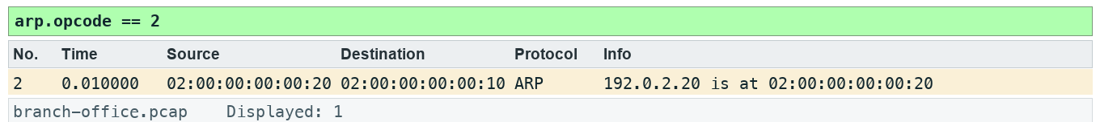
Lab 10 expected evidence — the packet list your filter should produce
Troubleshooting
TShark not found: install Wireshark CLI tools and add the installation folder to PATH; on Windows use the Wireshark install directory. A filter returns zero: clear other filters, use the specified capture, and check the expression is in the display toolbar. TLS remains opaque: select the matching lab-tls.keys file by absolute path, reload, and remove a key-log preference from another lab.
Try it with TShark
tshark -n -r data/branch-office.pcap -Y arp -T fields -e arp.opcode -e arp.src.proto_ipv4 -e arp.src.hw_mac
Challenge
Develop and explain an alternative filter.
Reflection
Which second observation point would strengthen your conclusion?
Extension (optional)
Ethernet and ARP lab — read the ARP cache on your own machine (arp -a) and match it to captured replies. Source: J.F. Kurose and K.W. Ross, Wireshark Labs (gaia.cs.umass.edu/kurose_ross/wireshark.php).
Note: Printable copy: labs/lab-10-verify-link-local-resolution/LAB-10-Instructions.pdf. Use the README in the matching labs/lab-NN-title/ folder. Capture only with permission.

Topic 11 — IPv4 Traffic Analysis
Classify IPv4 scope and headers
Key concepts
- TTL limits forwarding hops; it is not a latency measurement.
- Broadcast and multicast use different addressing scopes and delivery rules.
- Fragmentation fields describe packet handling; missing fragments can reflect capture limitations.
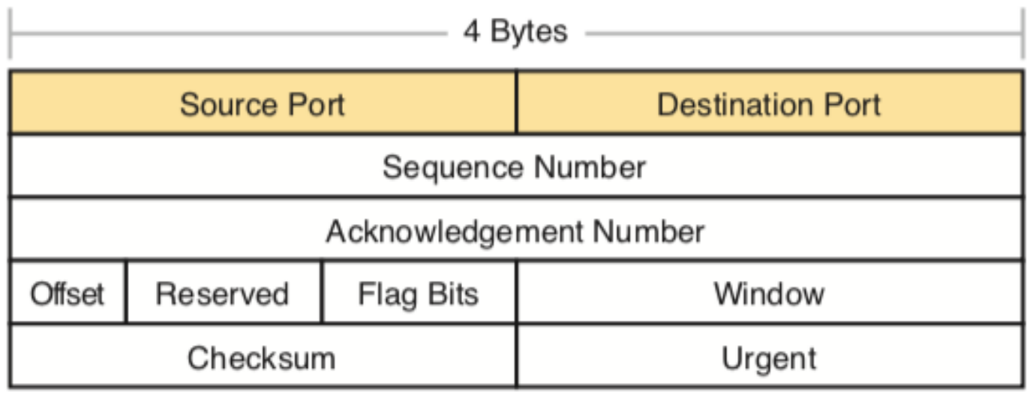
IPv4 Header Essentials — Header layout (TCP header shown; IPv4 uses the same 32-bit rows)

Lab 11 — Classify IPv4 scope and headers
Learning outcome: LO3.
Goal: TTL limits forwarding hops; it is not a latency measurement.
What you'll build
Evidence CSV and packet findings (Tools: Wireshark, TShark, Python.)
Step-by-step
1. Prepare your lab workspace. Open this lab folder in a terminal. Windows uses py -3 in place of python3. Wireshark GUI alone is sufficient for the investigation; CLI scripts require TShark on PATH. Run the fixture verification first.
python3 scripts/verify.py
2. Open data/branch-office.pcap. Select an ICMP echo request. Expand IPv4 and record version, IHL, total length, TTL, protocol, flags and fragment offset.
3. Apply ip.dst == 224.0.0.1 and compare Ethernet destination 01:00:5e:00:00:01 with IPv4 multicast destination. Record TTL 1.
4. Apply ip.flags.mf == 1 || ip.frag_offset > 0. Confirm no fragmented packets in this fixture; absence here does not demonstrate a universal MTU.
5. Complete assets/ip-header.csv. Explain why ARP broadcast is not an IPv4 broadcast packet, and why a capture at one point cannot estimate hop count from TTL without knowing initial TTL.
6. Export a reproducible packet table. Record the filter, frame numbers, measurement, explanation and limitation in outputs/findings.md.
python3 scripts/export_evidence.py
Test it
The supplied ip.dst == 224.0.0.1 expression matches 1 frame(s) in the specified capture. Run scripts/verify.py and compare the listed frame numbers. Keep your findings and exported table in outputs/. Explain the observed result rather than only copying a count.
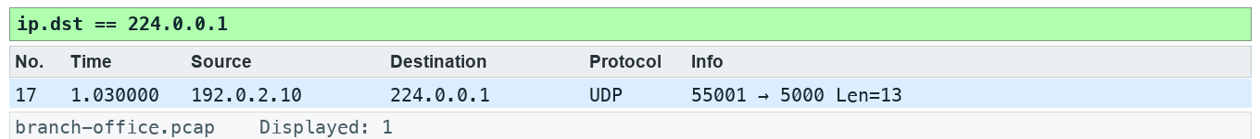
Lab 11 expected evidence — the packet list your filter should produce
Troubleshooting
TShark not found: install Wireshark CLI tools and add the installation folder to PATH; on Windows use the Wireshark install directory. A filter returns zero: clear other filters, use the specified capture, and check the expression is in the display toolbar. TLS remains opaque: select the matching lab-tls.keys file by absolute path, reload, and remove a key-log preference from another lab.
Try it with TShark
tshark -n -r data/branch-office.pcap -Y "ip.dst == 224.0.0.1" -T fields -e eth.dst -e ip.dst -e ip.ttl
Challenge
Develop and explain an alternative filter.
Reflection
Which second observation point would strengthen your conclusion?
Extension (optional)
IP lab — study TTL and fragmentation in the traceroute trace from the Kurose & Ross labs. Source: J.F. Kurose and K.W. Ross, Wireshark Labs (gaia.cs.umass.edu/kurose_ross/wireshark.php).
Note: Printable copy: labs/lab-11-classify-ipv4-scope-and-headers/LAB-11-Instructions.pdf. Use the README in the matching labs/lab-NN-title/ folder. Capture only with permission.

Topic 12 — ICMP Traffic Analysis
Interpret echo and unreachable messages
Key concepts
- Echo requests/replies show an IP exchange; they do not guarantee an application works.
- Destination unreachable messages quote the offending datagram.
- ICMP may be filtered or rate-limited, so absence of a reply needs cautious interpretation.
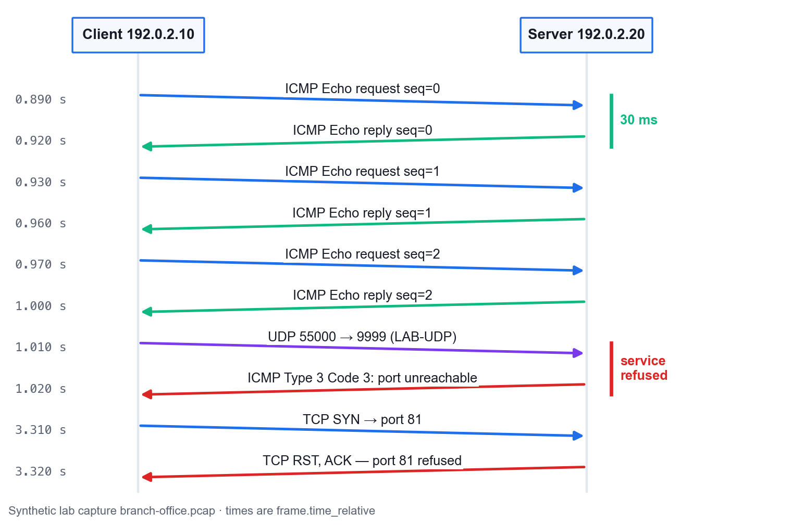
Echo, Refusal and Reset in the Lab Capture — Frames 9–16 and 55–56

Lab 12 — Interpret echo and unreachable messages
Learning outcome: LO3.
Goal: Echo requests/replies show an IP exchange; they do not guarantee an application works.
What you'll build
Evidence CSV and packet findings (Tools: Wireshark, TShark, Python.)
Step-by-step
1. Prepare your lab workspace. Open this lab folder in a terminal. Windows uses py -3 in place of python3. Wireshark GUI alone is sufficient for the investigation; CLI scripts require TShark on PATH. Run the fixture verification first.
python3 scripts/verify.py
2. Open data/branch-office.pcap. Apply icmp.type == 8 || icmp.type == 0. Pair echo sequences 0, 1 and 2 using identifier 7. Measure 0.030 seconds per pair.
3. Apply icmp.type == 3 && icmp.code == 3. Expand the quoted IPv4 and UDP headers. Record destination UDP port 9999.
4. Apply udp.dstport == 9999 to locate the initiating datagram. Record the difference between a UDP service refusal and an echo reply.
5. Complete assets/icmp-events.csv with type, code, quoted protocol, port and conclusion. State which evidence supports a service refusal.
6. Export a reproducible packet table. Record the filter, frame numbers, measurement, explanation and limitation in outputs/findings.md.
python3 scripts/export_evidence.py
Test it
The supplied icmp.type == 3 && icmp.code == 3 expression matches 1 frame(s) in the specified capture. Run scripts/verify.py and compare the listed frame numbers. Keep your findings and exported table in outputs/. Explain the observed result rather than only copying a count.
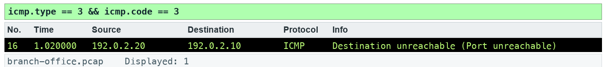
Lab 12 expected evidence — the packet list your filter should produce
Troubleshooting
TShark not found: install Wireshark CLI tools and add the installation folder to PATH; on Windows use the Wireshark install directory. A filter returns zero: clear other filters, use the specified capture, and check the expression is in the display toolbar. TLS remains opaque: select the matching lab-tls.keys file by absolute path, reload, and remove a key-log preference from another lab.
Try it with TShark
tshark -n -r data/branch-office.pcap -Y icmp -T fields -e frame.number -e icmp.type -e icmp.code -e icmp.seq
Challenge
Develop and explain an alternative filter.
Reflection
Which second observation point would strengthen your conclusion?
Extension (optional)
ICMP lab — identify Time Exceeded (type 11) messages in the traceroute trace. Source: J.F. Kurose and K.W. Ross, Wireshark Labs (gaia.cs.umass.edu/kurose_ross/wireshark.php).
Note: Printable copy: labs/lab-12-interpret-echo-and-unreachable-messages/LAB-12-Instructions.pdf. Use the README in the matching labs/lab-NN-title/ folder. Capture only with permission.

Topic 13 — UDP Traffic Analysis
Follow datagrams and service refusal
Key concepts
- UDP has no transport handshake or retransmission; the application may provide reliability.
- A port number is a decoding hint; payload and context identify the application.
- Following a UDP stream collects datagrams and does not invent missing data.
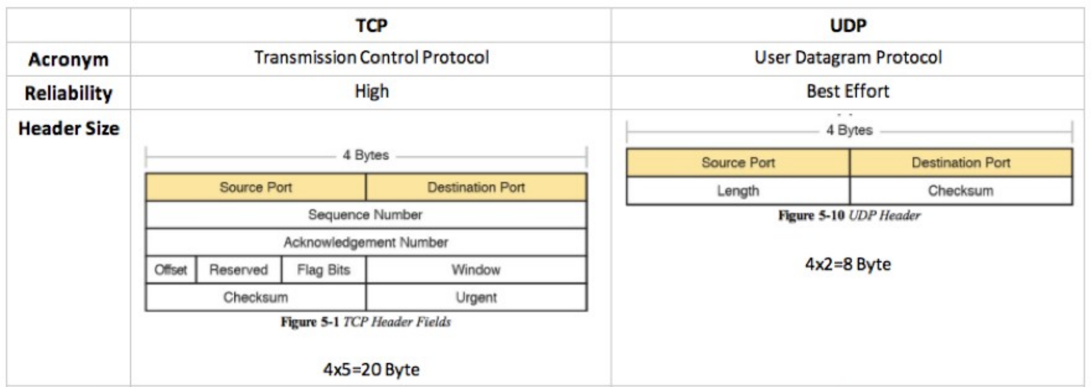
TCP vs UDP — Header and feature comparison

Lab 13 — Follow datagrams and service refusal
Learning outcome: LO3.
Goal: UDP has no transport handshake or retransmission; the application may provide reliability.
What you'll build
Evidence CSV and packet findings (Tools: Wireshark, TShark, Python.)
Step-by-step
1. Prepare your lab workspace. Open this lab folder in a terminal. Windows uses py -3 in place of python3. Wireshark GUI alone is sufficient for the investigation; CLI scripts require TShark on PATH. Run the fixture verification first.
python3 scripts/verify.py
2. Open data/branch-office.pcap. Apply udp.dstport == 9999. One frame is the original datagram and one is the UDP header quoted inside ICMP; inspect the outer protocol to distinguish them.
3. Select the original datagram and use Analyze > Follow > UDP Stream. Confirm the payload LAB-UDP. Save a text view to outputs/udp-stream.txt.
4. Apply udp.port == 4002 and decode RTP using Analyze > Decode As. Compare datagram framing with the earlier TCP stream.
5. Record why no UDP transport ACK exists in the trace. Use the ICMP refusal to explain why an application can fail even though a datagram was transmitted.
6. Export a reproducible packet table. Record the filter, frame numbers, measurement, explanation and limitation in outputs/findings.md.
python3 scripts/export_evidence.py
Test it
The supplied udp.dstport == 9999 expression matches 2 frame(s) in the specified capture. Run scripts/verify.py and compare the listed frame numbers. Keep your findings and exported table in outputs/. Explain the observed result rather than only copying a count.
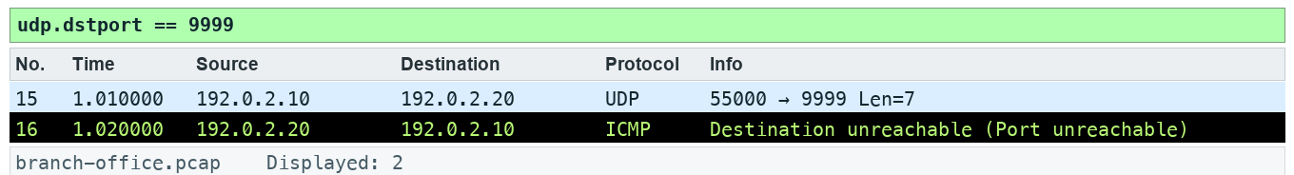
Lab 13 expected evidence — the packet list your filter should produce
Troubleshooting
TShark not found: install Wireshark CLI tools and add the installation folder to PATH; on Windows use the Wireshark install directory. A filter returns zero: clear other filters, use the specified capture, and check the expression is in the display toolbar. TLS remains opaque: select the matching lab-tls.keys file by absolute path, reload, and remove a key-log preference from another lab.
Try it with TShark
tshark -n -r data/branch-office.pcap -q -z follow,udp,ascii,3
Challenge
Develop and explain an alternative filter.
Reflection
Which second observation point would strengthen your conclusion?
Extension (optional)
UDP lab — examine UDP header fields and lengths in the UDP trace from the Kurose & Ross labs. Source: J.F. Kurose and K.W. Ross, Wireshark Labs (gaia.cs.umass.edu/kurose_ross/wireshark.php).
Note: Printable copy: labs/lab-13-follow-datagrams-and-service-refusal/LAB-13-Instructions.pdf. Use the README in the matching labs/lab-NN-title/ folder. Capture only with permission.

Topic 14 — TCP Protocol Analysis
Investigate retransmission and zero window
Key concepts
- Sequence numbers count bytes; ACK numbers indicate the next expected byte.
- Retransmission and duplicate ACK labels are heuristics sensitive to capture placement and completeness.
- Zero window indicates receive-side flow control; it is distinct from network congestion.
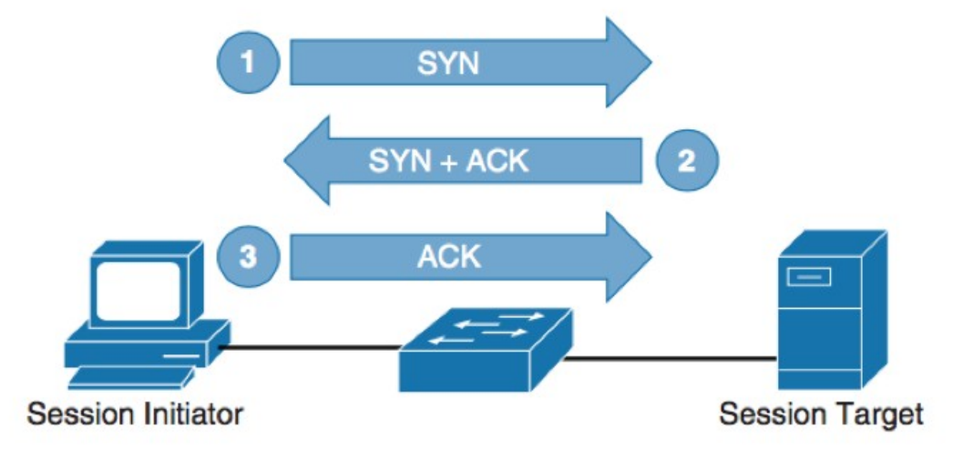
The Three-Way Handshake — Connection establishment

Lab 14 — Investigate retransmission and zero window
Learning outcome: LO4.
Goal: Sequence numbers count bytes; ACK numbers indicate the next expected byte.
What you'll build
Evidence CSV and packet findings (Tools: Wireshark, TShark, Python.)
Step-by-step
1. Prepare your lab workspace. Open this lab folder in a terminal. Windows uses py -3 in place of python3. Wireshark GUI alone is sufficient for the investigation; CLI scripts require TShark on PATH. Run the fixture verification first.
python3 scripts/verify.py
2. Open data/branch-office.pcap. Apply tcp.stream == 3. Open Analyze > Expert Information and note the repeated server segment.
3. Apply tcp.analysis.retransmission and expand TCP. Compare the same sequence range and payload in the earlier segment; the repeat occurs 1.000 second later.
4. Apply tcp.window_size_value == 0. Confirm the client ACK advertises zero receive window in stream 3. Examine the SYN options: window scaling is negotiated, but zero remains zero.
5. Apply tcp.flags.reset == 1. Identify the port 81 refusal. Complete assets/tcp-evidence.csv with stream, frame, flag/analysis, measured interval and a limitation. Discuss SACK, fast recovery and out-of-order evidence without claiming those events occur in this fixture.
6. Export a reproducible packet table. Record the filter, frame numbers, measurement, explanation and limitation in outputs/findings.md.
python3 scripts/export_evidence.py
Test it
The supplied tcp.analysis.retransmission expression matches 1 frame(s) in the specified capture. Run scripts/verify.py and compare the listed frame numbers. Keep your findings and exported table in outputs/. Explain the observed result rather than only copying a count.
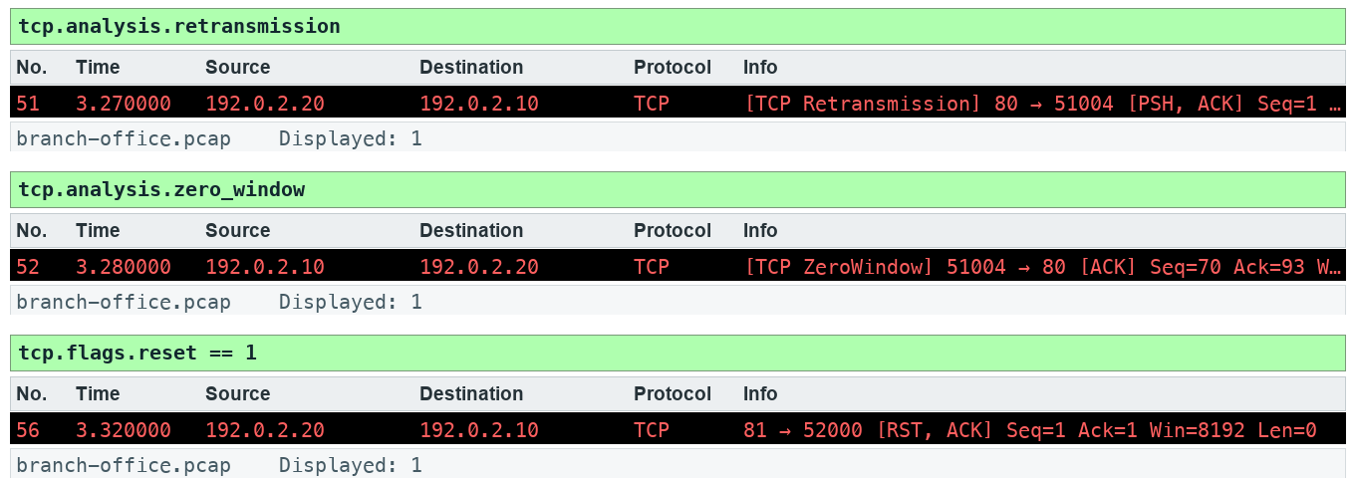
Lab 14 expected evidence — the packet list your filter should produce
Troubleshooting
TShark not found: install Wireshark CLI tools and add the installation folder to PATH; on Windows use the Wireshark install directory. A filter returns zero: clear other filters, use the specified capture, and check the expression is in the display toolbar. TLS remains opaque: select the matching lab-tls.keys file by absolute path, reload, and remove a key-log preference from another lab.
Try it with TShark
tshark -n -r data/branch-office.pcap -q -z expert
Challenge
Develop and explain an alternative filter.
Reflection
Which second observation point would strengthen your conclusion?
Extension (optional)
TCP lab — find retransmissions and window behaviour in a larger file transfer trace. Source: J.F. Kurose and K.W. Ross, Wireshark Labs (gaia.cs.umass.edu/kurose_ross/wireshark.php).
Note: Printable copy: labs/lab-14-investigate-retransmission-and-zero-window/LAB-14-Instructions.pdf. Use the README in the matching labs/lab-NN-title/ folder. Capture only with permission.

Topic 15 — Traffic Graphs
Graph bytes, RTT and recovery
Key concepts
- An I/O graph bins observed events; units and interval determine what it means.
- TCP time-sequence graphs show byte progress, stalls and repeated sequence ranges.
- RTT samples, application response time and throughput answer different questions.
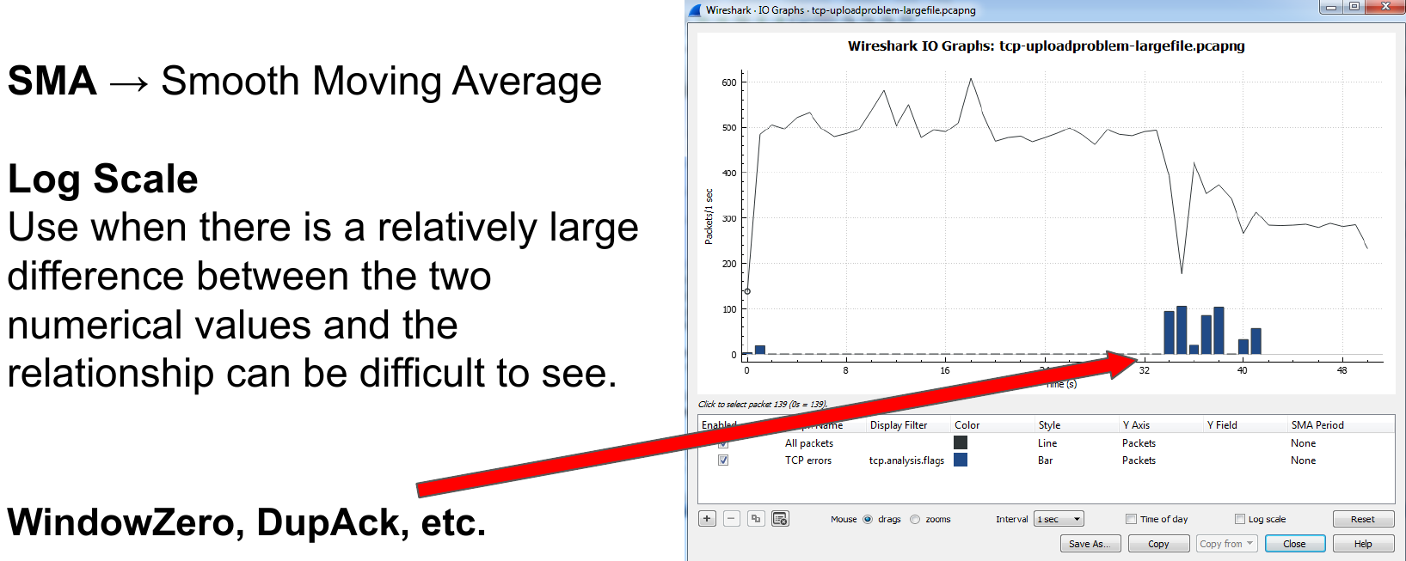
I/O Graphs — Multiple graphs with different filters on one chart

Lab 15 — Graph bytes, RTT and recovery
Learning outcome: LO4.
Goal: An I/O graph bins observed events; units and interval determine what it means.
What you'll build
Evidence CSV and packet findings (Tools: Wireshark, TShark, Python.)
Step-by-step
1. Prepare your lab workspace. Open this lab folder in a terminal. Windows uses py -3 in place of python3. Wireshark GUI alone is sufficient for the investigation; CLI scripts require TShark on PATH. Run the fixture verification first.
python3 scripts/verify.py
2. Open data/branch-office.pcap. Select a packet in TCP stream 3. Open Statistics > TCP Stream Graphs > Time Sequence (Stevens) and inspect the repeated server sequence.
3. Open Statistics > I/O Graphs. Add a retransmission graph with filter tcp.analysis.retransmission and a zero-window graph with filter tcp.analysis.zero_window. Use packets and a 1 second interval; record their event bins.
4. Open TCP Stream Graphs > Round Trip Time. Compare eligible ACK samples with the 30 ms SYN-to-SYN/ACK interval and the 40 ms complete handshake/initial_rtt on the final ACK. Explain why no ACK sample exists for an unacknowledged segment before its repeat.
5. Run the report script to export timestamps and byte lengths, then write outputs/graph-notes.md with interval, unit, stream, visible pattern and limitation. Do not use SUM(tcp.seq) as throughput.
6. Export a reproducible packet table. Record the filter, frame numbers, measurement, explanation and limitation in outputs/findings.md.
python3 scripts/export_evidence.py
Test it
The supplied tcp.analysis.retransmission || tcp.analysis.zero_window expression matches 2 frame(s) in the specified capture. Run scripts/verify.py and compare the listed frame numbers. Keep your findings and exported table in outputs/. Explain the observed result rather than only copying a count.
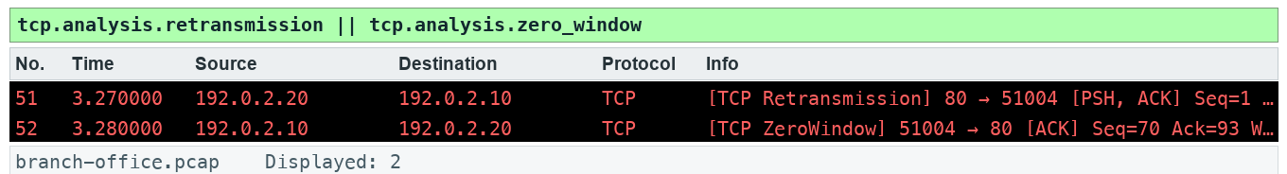
Lab 15 expected evidence — the packet list your filter should produce
Troubleshooting
TShark not found: install Wireshark CLI tools and add the installation folder to PATH; on Windows use the Wireshark install directory. A filter returns zero: clear other filters, use the specified capture, and check the expression is in the display toolbar. TLS remains opaque: select the matching lab-tls.keys file by absolute path, reload, and remove a key-log preference from another lab.
Try it with TShark
tshark -n -r data/branch-office.pcap -q -z "io,stat,1,tcp.analysis.retransmission,tcp.analysis.zero_window"
Challenge
Develop and explain an alternative filter.
Reflection
Which second observation point would strengthen your conclusion?
Extension (optional)
TCP lab — draw the Stevens graph of the file upload trace and estimate throughput. Source: J.F. Kurose and K.W. Ross, Wireshark Labs (gaia.cs.umass.edu/kurose_ross/wireshark.php).
Note: Printable copy: labs/lab-15-graph-bytes-rtt-and-recovery/LAB-15-Instructions.pdf. Use the README in the matching labs/lab-NN-title/ folder. Capture only with permission.

Topic 16 — HTTP and HTTP/2 Analysis
Inspect HTTP outcomes and HTTP/2 frames
Key concepts
- HTTP response codes describe application outcomes after transport delivery.
- A response time contains more than network latency; pair the correct request and response.
- HTTP/2 multiplexes frames; encrypted HTTP/2 needs authorised TLS secrets to inspect payload.
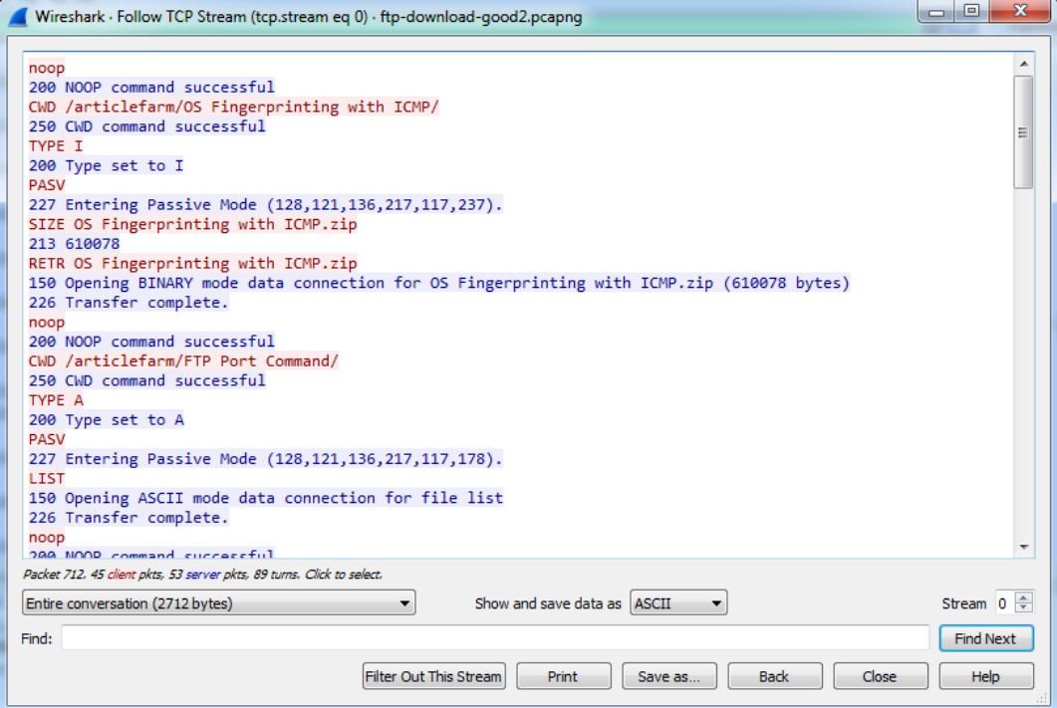
Follow the Stream — Follow Stream reassembles the transferred data

Lab 16 — Inspect HTTP outcomes and HTTP/2 frames
Learning outcome: LO4.
Goal: HTTP response codes describe application outcomes after transport delivery.
What you'll build
Evidence CSV and packet findings (Tools: Wireshark, TShark, Python.)
Step-by-step
1. Prepare your lab workspace. Open this lab folder in a terminal. Windows uses py -3 in place of python3. Wireshark GUI alone is sufficient for the investigation; CLI scripts require TShark on PATH. Run the fixture verification first.
python3 scripts/verify.py
2. Open data/branch-office.pcap. Apply http.request || http.response. Pair /health, /slow, /missing and /fault with their response codes.
3. Select the /health response and Follow > TCP Stream. Confirm LAB-OK. Use File > Export Objects > HTTP to save the health text object into outputs/objects/.
4. Apply tcp.port == 8080. Use Analyze > Decode As and set TCP port 8080 to HTTP2. Inspect the connection preface and SETTINGS frame (type 4). This fixture uses cleartext prior knowledge, not HTTPS.
5. Run scripts/verify.py, then save outputs/http-summary.csv with URI, status, response interval and proposed next step. Discuss how multiple HTTP/2 stream IDs share one TCP connection.
6. Export a reproducible packet table. Record the filter, frame numbers, measurement, explanation and limitation in outputs/findings.md.
python3 scripts/export_evidence.py
Test it
The supplied http.response.code >= 400 expression matches 2 frame(s) in the specified capture. Run scripts/verify.py and compare the listed frame numbers. Keep your findings and exported table in outputs/. Explain the observed result rather than only copying a count.
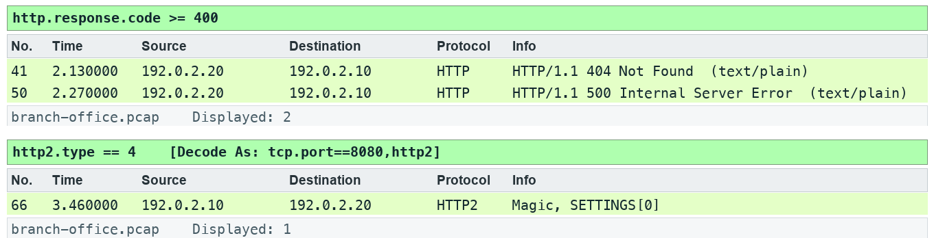
Lab 16 expected evidence — the packet list your filter should produce
Troubleshooting
TShark not found: install Wireshark CLI tools and add the installation folder to PATH; on Windows use the Wireshark install directory. A filter returns zero: clear other filters, use the specified capture, and check the expression is in the display toolbar. TLS remains opaque: select the matching lab-tls.keys file by absolute path, reload, and remove a key-log preference from another lab.
Try it with TShark
tshark -n -r data/branch-office.pcap -q --export-objects http,outputs/objects
Challenge
Develop and explain an alternative filter.
Reflection
Which second observation point would strengthen your conclusion?
Extension (optional)
HTTP lab — compare conditional GET (304) behaviour in the HTTP traces. Hash every exported object with shasum -a 256. Source: J.F. Kurose and K.W. Ross, Wireshark Labs (gaia.cs.umass.edu/kurose_ross/wireshark.php).
Note: Printable copy: labs/lab-16-inspect-http-outcomes-and-http-2-frames/LAB-16-Instructions.pdf. Use the README in the matching labs/lab-NN-title/ folder. Capture only with permission.

Topic 17 — TLS-Encrypted Traffic Analysis
Compare encrypted and decrypted views
Key concepts
- Without session secrets, encrypted application records do not disclose HTTP payload.
- A controlled key log enables authorised inspection of this synthetic TLS exchange.
- A server RSA private key alone cannot decrypt modern ECDHE or TLS 1.3 sessions.
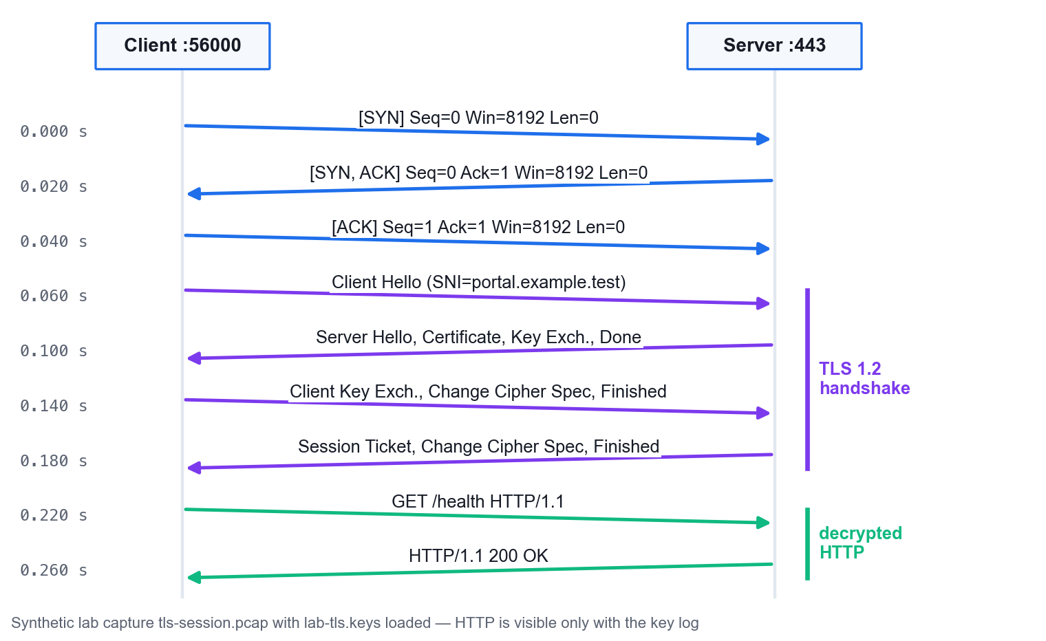
TLS 1.2 Handshake in the Lab Capture — tls-session.pcap, decrypted view

Lab 17 — Compare encrypted and decrypted views
Learning outcome: LO4.
Goal: Without session secrets, encrypted application records do not disclose HTTP payload.
What you'll build
Evidence CSV and packet findings (Tools: Wireshark, TShark, Python.)
Step-by-step
1. Prepare your lab workspace. Open this lab folder in a terminal. Windows uses py -3 in place of python3. Wireshark GUI alone is sufficient for the investigation; CLI scripts require TShark on PATH. Run the fixture verification first.
python3 scripts/verify.py
2. Open data/tls-session.pcap. In Preferences > Protocols > TLS, clear the (Pre)-Master-Secret log filename, then apply tls. Identify ClientHello and encrypted application records.
3. Expand ClientHello > Extensions > server_name. Record portal.example.test. The lab uses a real TLS 1.2 MemoryBIO exchange, a temporary self-signed certificate and offline synthetic TCP wrapping.
4. Set Preferences > Protocols > TLS > (Pre)-Master-Secret log filename to the absolute path of data/lab-tls.keys. Reload the capture. Apply http and confirm GET /health and 200 OK containing LAB-OK.
5. Run scripts/verify.py for both encrypted/decrypted checks. Clear the key-log preference when finished. The supplied secrets are synthetic lab session material; never copy production session secrets into a public repository.
6. Export a reproducible packet table. Record the filter, frame numbers, measurement, explanation and limitation in outputs/findings.md.
python3 scripts/export_evidence.py
Test it
The supplied tls.handshake.type == 1 expression matches 1 frame(s) in the specified capture. Run scripts/verify.py and compare the listed frame numbers. Keep your findings and exported table in outputs/. Explain the observed result rather than only copying a count.
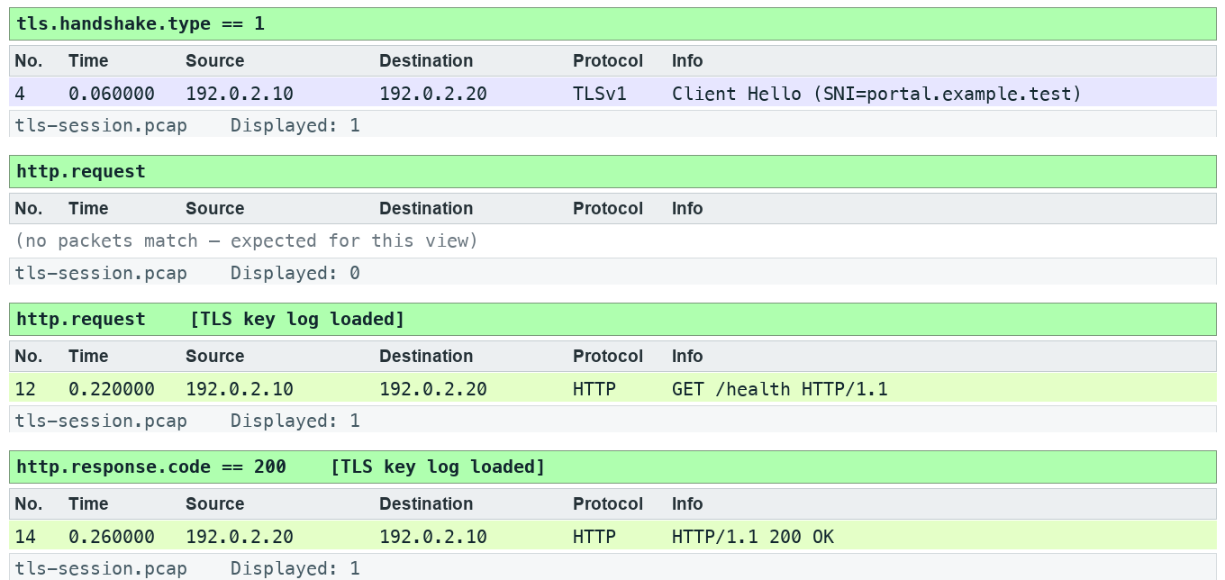
Lab 17 expected evidence — the packet list your filter should produce
Troubleshooting
TShark not found: install Wireshark CLI tools and add the installation folder to PATH; on Windows use the Wireshark install directory. A filter returns zero: clear other filters, use the specified capture, and check the expression is in the display toolbar. TLS remains opaque: select the matching lab-tls.keys file by absolute path, reload, and remove a key-log preference from another lab.
Try it with TShark
tshark -n -r data/tls-session.pcap -o tls.keylog_file:data/lab-tls.keys -Y http
Challenge
Develop and explain an alternative filter.
Reflection
Which second observation point would strengthen your conclusion?
Extension (optional)
TLS lab — identify the handshake records and cipher suite in the TLS trace from the Kurose & Ross labs. Source: J.F. Kurose and K.W. Ross, Wireshark Labs (gaia.cs.umass.edu/kurose_ross/wireshark.php).
Note: Printable copy: labs/lab-17-compare-encrypted-and-decrypted-views/LAB-17-Instructions.pdf. Use the README in the matching labs/lab-NN-title/ folder. Capture only with permission.

Topic 18 — Ten Troubleshooting Steps and Reporting
Produce an evidence-led incident report
Key concepts
- Begin with scope and a baseline, then focus with endpoints, filters, time and graphs.
- Separate observed facts from hypotheses and specify what new evidence would test them.
- A useful report states affected flow, measurement, impact, recommended action and uncertainty.
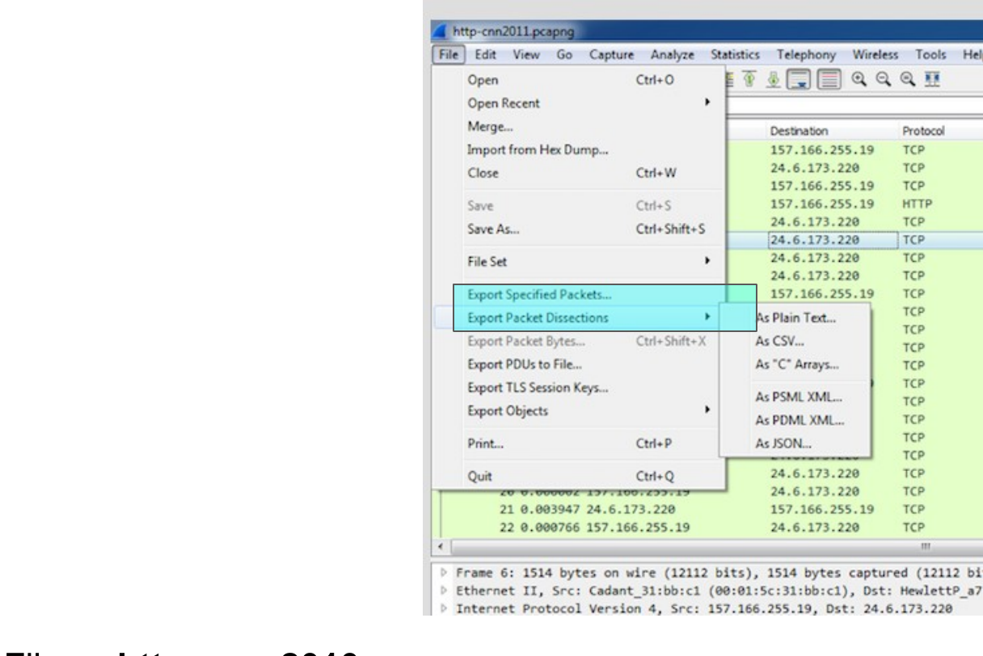
Export and Preserve Evidence — File | Export Packet Dissections

Lab 18 — Produce an evidence-led incident report
Learning outcome: LO5.
Goal: Begin with scope and a baseline, then focus with endpoints, filters, time and graphs.
What you'll build
Evidence CSV and packet findings (Tools: Wireshark, TShark, Python.)
Step-by-step
1. Prepare your lab workspace. Open this lab folder in a terminal. Windows uses py -3 in place of python3. Wireshark GUI alone is sufficient for the investigation; CLI scripts require TShark on PATH. Run the fixture verification first.
python3 scripts/verify.py
2. Open data/branch-office.pcap. Read assets/incident-ticket.md. Use Statistics > Conversations, filters and Expert Information to identify the failing /fault request.
3. Record evidence for the DNS delay, slow HTTP response, retransmission, zero window and port 81 refusal. Use exact frames and elapsed times rather than a claim that every symptom has one cause.
4. Complete assets/report-template.md and save as outputs/incident-report.md. Include scope, timeline, observations, competing explanations, next capture placement and a client-safe recommendation.
5. Use assets/ten-step-checklist.md to review the report. Re-run scripts/verify.py. Exchange reports with another learner and check that every conclusion can be traced to a packet or is explicitly a hypothesis.
6. Export a reproducible packet table. Record the filter, frame numbers, measurement, explanation and limitation in outputs/findings.md.
python3 scripts/export_evidence.py
Test it
The supplied http.response.code == 500 expression matches 1 frame(s) in the specified capture. Run scripts/verify.py and compare the listed frame numbers. Keep your findings and exported table in outputs/. Explain the observed result rather than only copying a count.
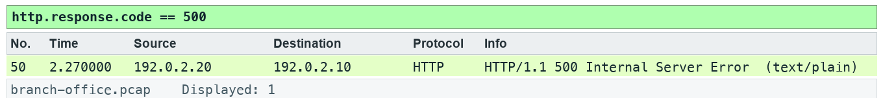
Lab 18 expected evidence — the packet list your filter should produce
Troubleshooting
TShark not found: install Wireshark CLI tools and add the installation folder to PATH; on Windows use the Wireshark install directory. A filter returns zero: clear other filters, use the specified capture, and check the expression is in the display toolbar. TLS remains opaque: select the matching lab-tls.keys file by absolute path, reload, and remove a key-log preference from another lab.
Try it with TShark
tshark -n -r data/branch-office.pcap -q -z conv,tcp
Challenge
Develop and explain an alternative filter.
Reflection
Which second observation point would strengthen your conclusion?
Extension (optional)
Write a second incident report from a capture in the Wireshark sample captures (wiki.wireshark.org/SampleCaptures), using the same template and checklist.
Note: Printable copy: labs/lab-18-produce-an-evidence-led-incident-report/LAB-18-Instructions.pdf. Use the README in the matching labs/lab-NN-title/ folder. Capture only with permission.

Next Steps
- Repeat a lab with a fresh analyst profile.
- Use the ten-step checklist on a new authorised capture.
- Preserve packet numbers, filters and limitations in every report.

Further Learning
These sources informed the course content and are recommended for extra practice. Kurose & Ross material is referenced with acknowledgement, as its terms require.
- Wireshark — Learn — https://www.wireshark.org/learn
- Kurose & Ross — Wireshark Labs (v9.0) — https://gaia.cs.umass.edu/kurose_ross/wireshark.php
- UMass — Wireshark lab files — https://gaia.cs.umass.edu/wireshark-labs/
- Cyber Defence Kit — Wireshark hands-on labs — https://docs.cyberdefencekit.org/wireshark/hands-on-labs.html
- LabEx — Wireshark tutorials — https://labex.io/tutorials/category/wireshark
- LabEx — Wireshark skill tree — https://labex.io/classroom/skilltrees/wireshark
- LabEx — learn-wireshark (GitHub) — https://github.com/labex-labs/learn-wireshark
- Wireshark.com — Learn — https://wireshark.com/learn/
- 101 Labs — Wireshark WCNA — https://www.101labs.net/courses/101-labs-wireshark-wcna/
- WPI CS3516 — Wireshark lab 1 — https://web.cs.wpi.edu/~cs3516/b09/wireshark/wire1/
- Wireshark sample captures — https://wiki.wireshark.org/SampleCaptures

Glossary
- Capture filter — libpcap expression limiting packets stored during capture.
- Display filter — Wireshark expression selecting stored packets for viewing.
- iRTT — Initial TCP round-trip sample from the handshake.
- Retransmission — Repeated TCP byte range; interpretation depends on capture completeness.
- Zero window — A receiver advertisement that no receive-buffer space is available.
- TLS key log — Per-session secrets permitting authorised decryption of the matching session.
- SPAN — Switch mirroring of selected traffic to a sensor port.
- TAP — An inline observation device supplying link traffic to a sensor.

